App/Resource | How We’ve Used It | Benefits | Challenges Faced
Quizlet | Online flashcards and quizzes for review | Good, quick review for students  Students finished work early can go online and practice instead of wasting time | The written answers need to be exact so do not select written questions
Gizmos | Density Laboratory  Electrical Circuits- did not work  Ionic Bonds- with 2Ls | 2Ls are always more engaged with technology. Gizmos are an easy and effective visual for them | Not all gizmos are compatible with iPads (even the app only provides a limited number of available gizmos)
Onlinecharttool.com  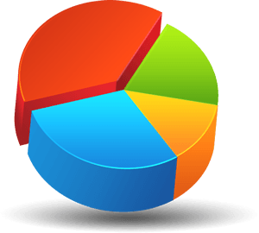 | Students created a graph showing the cooling curve of a substance to determine the temperatures at which a state change occurs. Once completed, they sent their graph to me via iMessage for review | Was able to give immediate feedback as students sent their graphs to me through imessage  Prevents students from lining up at my desk or holding up their hands to have their work reviewed- saves time | Requires me to be on the iPad instead of moving around the classroom.  Board removed iMessage from the iPads- need a new method for students to send their work to me
Schoology app | Course Website  Electronic files  Online testing | Reduces photocopying  Online quizzes and tests- students receive grade immediately | Wifi can disconnect- be sure to select “Resumable” when setting up test
Book creator | Assign students individual sections to create a study page for the final exam. Book is then merged and shared for all students for exam review | Very easy way for peers to collaborate  Students found the exam review very helpful  Able to print the PDF file so you can highlight and study from the book | Free app does not allow you to merge books  Difficult to reorder the pages because you’re unable to zoom to see the titles  Airdrop can take a lot of time  Comic panels were difficult to manipulate- use textboxes instead  Can’t click on links from PDF- need to copy and paste every time  Difficult to get pictures in the desired format
Educreations  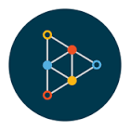 | Interactive whiteboard for video creation  3 main points in under 3 minutes- students summarized the 3 most important points from their Space presentations in a 3 minute video and posted it to schoology for other students to review | Easy to use for beginners  Easy to upload pictures  Can search online through the app  Lots of editing options  Can easily access pages/features as you record | Cannot trim recordings so editing mistakes/outside noise is difficult  Once shared, students cannot view videos on their phone (free version)  Cannot upload to youtube (free version)
Explain Everything | Interactive whiteboard for video creation  3 main points in under 3 minutes (see Educreations) | Fun features  Easy to use/ good textboxes  Easy to export as .mp4 or to youtube  Good video/voice recording  Easy to add photos  Easy to edit and trim recordings | Limited themes and colour choices  Some drawings looks childish on iPad if you are not experienced in drawing on iPad- difficult to edit doodles- lose the entire picture
Piktochart  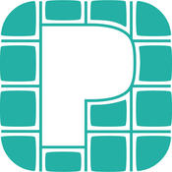 | Instead of making a poster, students created a poster on the piktochart website, can edit/view on app | Much easier to mark than carrying around posters  Students produced great products and were able to include more images and info  Students weren’t limited by their artistic abilities | App was not user friendly so students used the website instead  Requires payment for easy sharing methods- free is just copying the link once shared
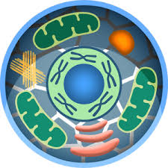  Cell World | Explore the cell, zooming in on different organelles/parts of the cell | Students can use their headphones and it will read it to them- good for 2Ls
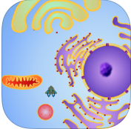  Cell Explorer | Game to explore the cell- students have to maintain energy from ATP and locate different organelles while avoiding being consumed by the lysosomes | Game – fun way, helps them locate organelles | Some aspects of game context are not relevant
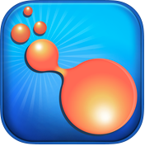  Biotic | Students perform the different stages of mitosis and meiosis on a cell by following instructions | Good review for understanding what happens at each stage and in what order | Must pay for intermediate and expert levels, Novice level is free (but good enough for SNC2L,P,D)
Mitosis | Students read about and perform the different stages of mitosis on a cell by following instructions  Use preloaded images to help find different phases on microscope slides | Explore and Quiz options  Preloaded labeled images (drawings and microscopic) and videos | Some terms are too advanced for grade 10
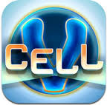  VCell | Students can explore a variety of videos, images, information and quizzes on various cellular topics (mitosis, photosynthesis, respiration) | All have labeled computer animated images, and the option of viewing different media. | Some terms are too advanced for grade 10
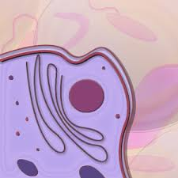  iCell | Explore the cell, zooming in on different organelles/parts of the animal and plant cell (Also see Cell World) | Tap on organelle to receive information  Choose between Basic, Intermediate, and Advanced information, tap on organelles for | All graphics are in 3D and do not look like what they are used to (ex. Mitochondria)
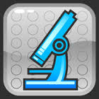  AnimalHistology & PlantHistology | Students explore the different stages of the cell cycle and Mitosis, and can quiz themselves on the different cycles using real microscope images. | Study – gives information on the different stages of the cell cycle, as well as phases of Mitosis  Practice – gives images to identify as stage of mitosis | Practice only has 7 questions that are always the same, but in different order
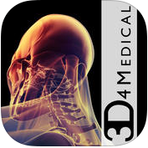  Images and Anatomy  3D4Medical | Students can view different anatomical systems of the body | Students can visualize how the body systems all fit into the human body | Some content too in depth and advanced for grade 10
Nova Elements App  Element Builder  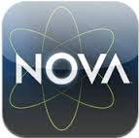 | Students “build” different atoms (adding subatomic particles) | Good break from drawing B-R diagrams repeatedly  Can use the atoms once built to make large molecules | It does a bit of the work for you (filling orbits automatically etc) – doesn’t require as much thought
Nova Elements Interactive Periodic Table app | Research for projects  Quick research on element properties | Quick information for elements including physical and chemical properties | Videos cannot be accessed outside USA
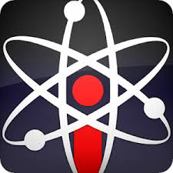  Chem Pro | Practice Quizzes and flashcards for chemical names and symbols | Good review activity to help student prepare for quiz | Can’t select the elements that you want to include (if you limit the number that students need to know)
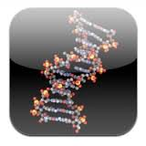  Molecules | View 3D images/models of molecular structure | Check to see if their created models are correct, or to investigate trends between similar molecules
Elements 4D | Use printable templates - augmented reality, can show bonding, balanced chemical reactions, physical properties | Shows images of the elements as well as physical properties once they bond with other atoms (by placing two cubes side by side) | Students need to cut and glue the nets together which can be a bit time consuming
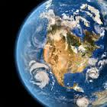  Our Choice | Students can investigate different aspects of climate change | Interactive eBook  Questions embedded in videos | Long load time
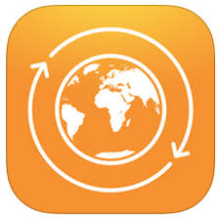  Global Change | Shows carbon and water cycles and the effects of changing the balance within each cycle |  | Must download lesson each time the apps loads up
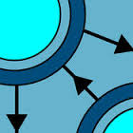  Food Webs | Food web builder in 3 different types of ecosystems | Provides information on species ecological niche so students can easily make connections in a food web | Limited to Australian ecosystems
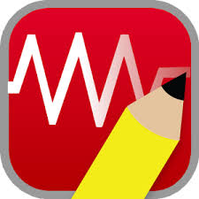  DC Circuit Builder | Build simple DC circuits and tests for electrical quantities using a voltmeter and ammeter | Quick and easy to build a circuit, shows conventional current, can change battery voltage | No switches, shows + charges moving for conventional current, does not show electron flow, can only use one voltmeter
Circuit Blitz | Game - used for extra practice and students that are finished early, helps students understand the nature of a closed path circuit | Students have to fix a circuit and bypass certain loads to meet specific criteria in a time sensitive manner | Students who do not have an understanding of electric potential differences may struggle in higher levels
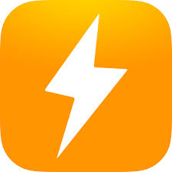  Grid Watch (Ontario Edition) | Provides up-to-date (hourly) information on Ontario’s power generation stations, including overall demand and output. | Can view where all power stations are located in Ontario, and their capacities. | Can only see daily trends and hourly generation values
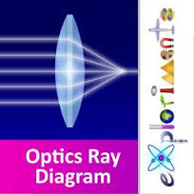  Ray Optics | Students can investigate ray tracing of objects in mirrors and lenses | Can easily change image location, height, lenses, mirrors, and what the image would actually look like
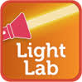  LightLab | Game: students use their knowledge of refraction to place lenses and prisms in the way of a photon beam to hit a target | Fun way to show application of refraction of light in prisms and lenses | Shows light as photons
Star Chart and Skyview  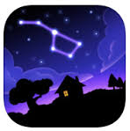 | View and locate stars and constellations.  Skyview- point to sky and see what is out there now  Star Chart- find star or constellation as a game | Students can click on stars and constellations to get more information  More accurate views that hand drawn star charts | Can be challenging for students to use with limited knowledge of the location of celestial objects
NASA | Use for research and to find up to date articles from NASA | Easy way to get up to date info | General- not as specific to one topic

